AI ASSISTED CODING
ASSIGNMENT -13.2
NAME:G.VARSHITH RAJU
ROLL NO:2503A51L02

Task Description #1 – Remove Repetition
Task: Provide AI with the following redundant code and ask it to refactor
Python Code
def calculate_area(shape, x, y=0):
if shape == "rectangle":
return x * y
elif shape == "square":
return x * x
elif shape == "circle":
return 3.14 * x * x
Expected Output
• Refactored version with dictionary-based dispatch or separate functions.
• Cleaner and modular design
PROMPT:
Python Code
def calculate_area(shape, x, y=0):
if shape == "rectangle":
return x * y
elif shape == "square":
return x * x
elif shape == "circle":
return 3.14 * x * x
for this code give Refactored version with dictionary-based dispatch or separate
functions with Cleaner and modular design.
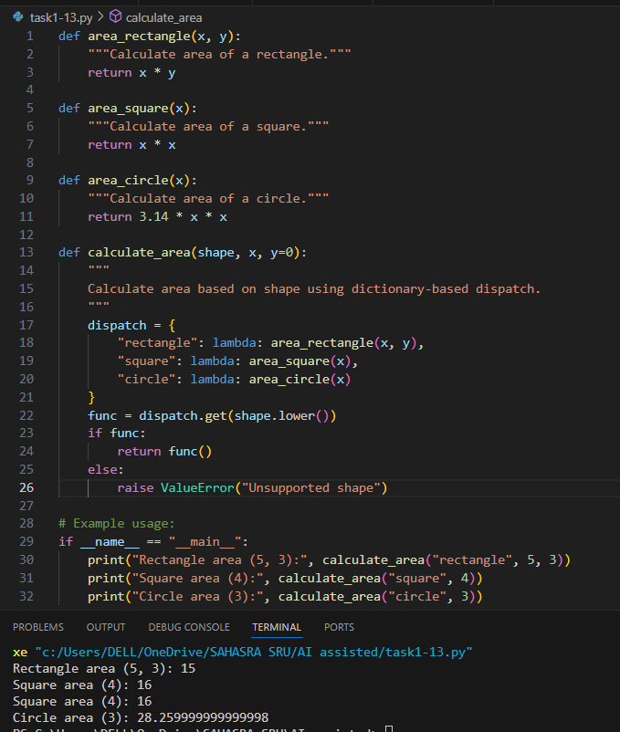
OUTPUT:
OBSERVATION:
The code was refactored from using multiple if-elif statements inside the calculate_area function to a cleaner, modular design. Now, each shape's area calculation is handled by a separate function, and a dictionary-based dispatch is used to select the correct function based on the shape.

Task Description #2 – Error Handling in Legacy Code
Task: Legacy function without proper error handling
Python Code
def read_file(filename):
f = open(filename, "r")
data = f.read()
f.close()
return data
Expected Output:
AI refactors with with open() and try-except

PROMPT:
def read_file(filename):
f = open(filename, "r")
data = f.read()
f.close()
return data for the above code refactor with with open() and try-except let user give input to open and read the file.

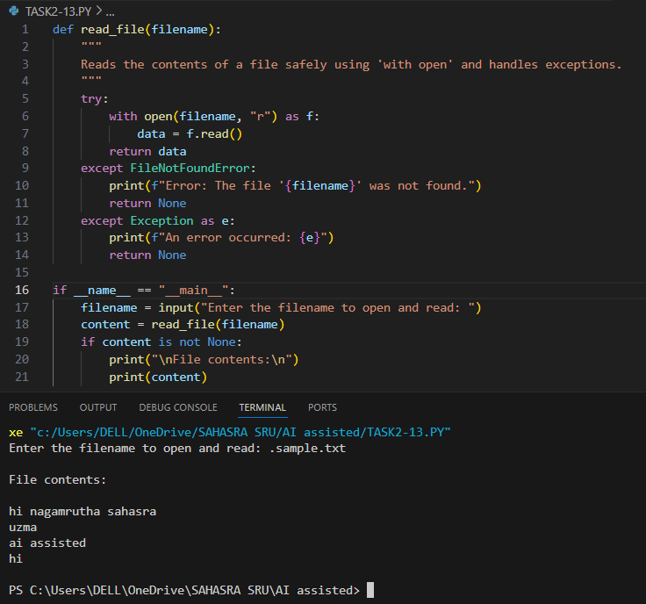

OUTPUT:
OBSERVATION:
The code safely reads and displays the contents of a user-specified file using with open and exception handling. It prompts the user for a filename, reads the file if it exists, and prints its contents. Errors such as missing files are handled gracefully with clear messages.
Task Description #3 – Complex Refactoring
Task: Provide this legacy class to AI for readability and modularity improvements:
Python Code
class Student:
def __init__(self, n, a, m1, m2, m3):
self.n = n
self.a = a
self.m1 = m1
self.m2 = m2
self.m3 = m3
def details(self):
print("Name:", self.n, "Age:", self.a)
def total(self):
return self.m1+self.m2+self.m3
Expected Output:
• AI improves naming (name, age, marks).
• Adds docstrings.
• Improves print readability.
• Possibly uses sum(self.marks) if marks stored in a list
PROMPT:
class Student:
def __init__(self, n, a, m1, m2, m3):
self.n = n
self.a = a
self.m1 = m1
self.m2 = m2
self.m3 = m3
def details(self):
print("Name:", self.n, "Age:", self.a)
def total(self):
return self.m1+self.m2+self.m3
for the above code improve naming (name, age, marks). Add docstrings and use sum(self.marks) if marks stored in a list.
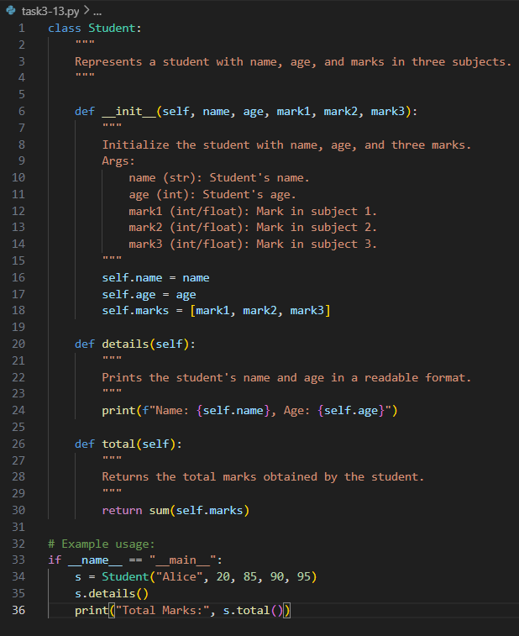

OUTPUT:
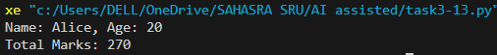
OBSERVATION:
The code now allows the user to input a student's name, age, and marks interactively. It stores the marks in a list for better structure and uses clear, descriptive variable names. The program prints the student's details and the total marks in a readable format, making it user-friendly and easy to maintain.
Task Description #4 – Inefficient Loop Refactoring
Task: Refactor this inefficient loop with AI help
Python Code
nums = [1,2,3,4,5,6,7,8,9,10]
squares = []
for i in nums:
squares.append(i * i)
Expected Output: AI suggested a list comprehension
PROMPT:
Python Code
nums = [1,2,3,4,5,6,7,8,9,10]
squares = []
for i in nums:
squares.append(i * i)
refactor the above code and suggest a list comprehension and print a example square
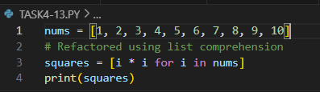

OUTPUT:
OBSERVATION:
The code efficiently generates a list of squares for numbers 1 to 10 using list comprehension, making it more concise and readable compared to a traditional loop. The output displays all the squared values in a single list.

